**ASSIGNMENT 1 FRONT SHEET**

|  |  |  |  |
| --- | --- | --- | --- |
| **Qualification** | **TEC Level 5 HND Diploma in Computing** | | |
| **Unit number and title** | **Unit 04: Database Design & Development** | | |
| **Submission date** |  | **Date Received 1st submission** |  |
| **Re-submission Date** |  | **Date Received 2nd submission** |  |
| **Student Name** | Trần Văn Khởi | **Student ID** | BH00082 |
| **Class** | IT0501 | **Assessor name** | Nguyễn Thái Cường |
| **Student declaration**  I certify that the assignment submission is entirely my own work and I fully understand the consequences of plagiarism. I understand that making a false declaration is a form of malpractice. | | | |
|  |  | **Student’s signature** |  |

**Grading grid**

|  |  |  |
| --- | --- | --- |
| P1 | M1 | D1 |
|  |  |  |

|  |  |  |
| --- | --- | --- |
| **❒ Summative Feedback: ❒ Resubmission Feedback:** | | |
| **Grade:** | **Assessor Signature:** | **Date:** |
| **Signature & Date:** | | |

Table of Contents

I. Introduction 3

II. Content 4

1. Database Design 4

a. Scenario of the chosen system 4

b. SRS (System Requirement Specification) 4

a. Introduction 5

* High Level Requirement 6

b. SRS-Object Relationship Diagram 7

c. Security Requirement 8

d. Use Case Specification 8

3. Logical design (ERD) 9

4. Logical design 9

5. Physical design 9

C.Conclusion 19

D.References 19

FIgure: 1:Introduction 6

FIgure: 2:SRS-Object Relationship Diagram 8

FIgure: 3:SQL sales management table 11

FIgure: 4:SQL sales management code 12

FIgure: 5:SQL sales management code 13

FIgure: 6;SQL sales management code 14

FIgure: 7:SQL sales management code 15

FIgure: 8:SQL sales management code 16

FIgure: 9:SQL sales management code 17

FIgure: 10:SQL sales management code 18

FIgure: 11:SQL sales management code 19

# I. Introduction

Hello teacher. My name is Tran Van Khoi, I am studying at British college BTEC FPT, I am currently studying in class IT0501. In this ASM lesson I will demonstrate the basic properties of SQL and how to create a sales management program on SQL: in ASM I will demonstrate the following:

- Database Design

+ Scenario of the chosen system

+ Present the scenario

+ SRS (System Requirement Specification)

+ Introduce and explain features of the system

- Logical design (ERD)

+ Explanation

Explain briefly about ERD (entities, their relationship). Give reasons why ERD is suitable for the system

+ Physical design

# II. Content

## 1. Database Design

### a. Scenario of the chosen system

I was hired as a database developer for a huge IT consulting firm, and in addition to everything, I created a little cafe for ABC employees. Students, professors, and others with sales expertise have approached the company's office. It decides to construct server academic systems to make managing the company's sales easier, including: restaurant quality and the ability to analyze the restaurant's food and beverage, as well as customer contentment. items,

### b. SRS (System Requirement Specification)

SRS stands for Software Requirement Specification and is a requirements specification document. This document details the system's functional and non-functional needs, as well as various data and interface requirements. Stakeholders can read and comprehend the transactions of the functions thanks to SRS. For software development and testing teams, this is a critical document.

* The role of SRS documentation in product development

* Help stakeholders understand the system in the same direction: Thanks to the SRS requirements specification document, all stakeholders, also known as third parties can easily understand the system in the right direction, avoiding the situation where each people understand differently.
* The development team relies on this to build the correct system: It is not easy for the features to be built according to the customer's requirements. So the software development team needs to have the SRS document to be able to build the system correctly, correctly, without getting lost.
* Help testers understand to write test cases: Software testers need to rely on this SRS document to understand and build the most detailed test scenarios.
* System maintenance and improvement: Thanks to the SRS documentation, it is faster and easier to maintain the system or improve the functions in the system.

* Main components of SRS requirements specification documents

### a. Introduction

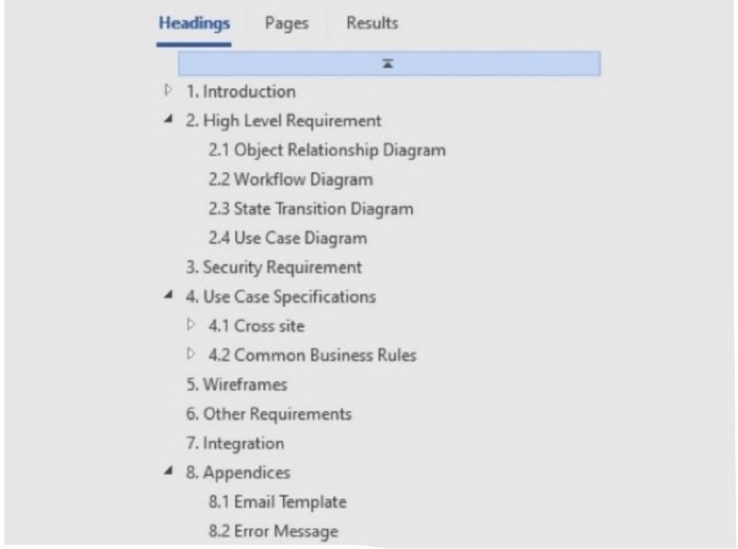

FIgure: 1:Introduction

* **Purpose**: This section is used to describe in detail the purpose and meaning of the SRS document, thereby helping readers better understand the concept and importance of this document.
* **Application Overview**: This section will help readers have an overview of the system they want to do. To ensure complete documentation, this section needs to include elements such as: an overview of the system, main features, rights to use, and what purpose this system is built for, for whom. …
* **Intended Audience and Reading Suggestions: It describes who uses the SRS document and what they need to do.**
* **Abbreviations**: Explain and define acronyms in the document.
* **References**: This section is used to attach related documents and descriptions.

### * High Level Requirement

Object Relationship Diagram: This model represents the static relationship between the objects stated in the system. An object is viewed as a specific entity in the system.

### b. SRS-Object Relationship Diagram

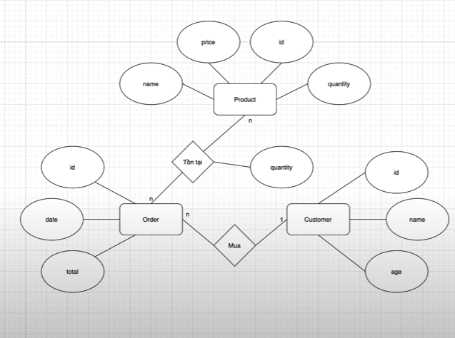

FIgure: 2:SRS-Object Relationship Diagram

* **Workflow Diagram:** This item displays the user's workflow or steps. Each user action will be displayed in each stage of the business process of the system.
* **State Transition Diagram:** This section describes the step-by-step state of the workflow, making it possible for the reader to see who the performer is and how it affects the state in the system's process.
* **Use Case Diagram:** This diagram shows how users use and interact with system features.

### c. Security Requirement

This section includes a complete description of the user's tasks and functions, in addition to indicating the user's rights. In addition, here also displays the matrix table of the tasks of each system user.

### d. Use Case Specification

This section contains the functional requirements of the system, accompanied by a detailed description of the tasks to be performed in terms of expected behaviour, inputs and outputs. In addition, this section also displays the interactions between external actors on the system and the results of that interaction.

**\* Wireframe**

The screen design is an item that allows attaching documents so that the reader can easily move to the system screen. As a result, it becomes faster to confirm system functional requirements with customers, and at the same time help customers easily understand and visualize the system, demonstrating the business analyst's understanding of customer requirements. service. In addition, this section also helps demonstrate the competence of the project team.

**\* Other Requirement**

Additional system requirements are detailed here. This section will be directed to the non-system requirements.

**\* Integration**

This section is used for the purpose of attaching documents related to external systems.

**\* Appendices**

This section allows users to define error messages or email templates used in the system.

## 3. Logical design (ERD)

- Entity Relationship Diagram (ERD) is an abbreviation for Entity Relationship Diagram. E (Entity) and R (Relationship) are included in this model (Relationship). The concept of ERD follows from there: An ERD model is a diagram that depicts the database's entities and their relationships.

- ERD aids in the discovery of related terms in the model. - Demonstrate the interconnection structure between the tables, making it easy to visualize the model's existence. - Describe three elements in detail: relationship, entity, and associated properties.

- Table SQL

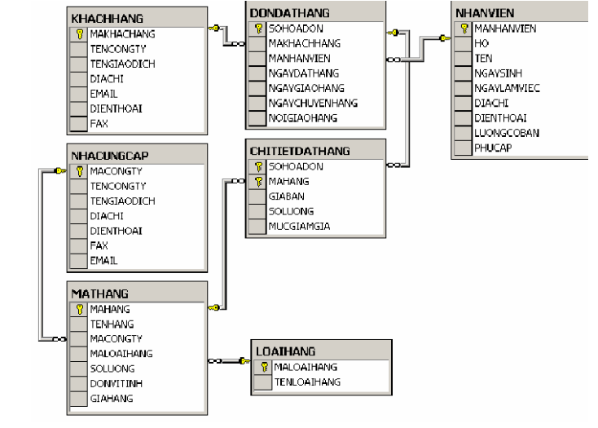

FIgure: 3:SQL sales management table

## 4. Explanation

- The NHACUNGCAP table stores data about the partners supplying the company.

-The MATHANG table stores data about the existing items in the company.

-The LOAIHANG table classifies the available items.

-The NHANVIEN table has data about employees working in the company

-The KHACHHANG table is used to store information about the company's customers.

-Customers place orders for the company through purchase orders. General information about orders is stored in the DONDATHANG table (Each order must be made by an employee of the company and therefore this table is related to the NHANVIEN table)

-Detailed information of orders (what items to order, quantity, price, etc.) is stored in the CHITIETDATHANG table, which has a relationship with the two tables DONDATHANG and MAHANG.

## 5. Physical design

- Code SQL:

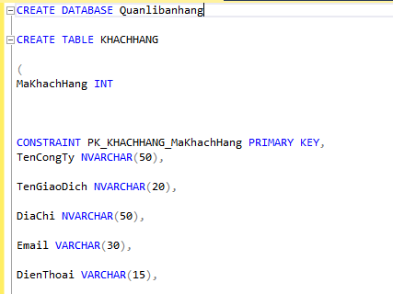

FIgure: 4:SQL sales management code

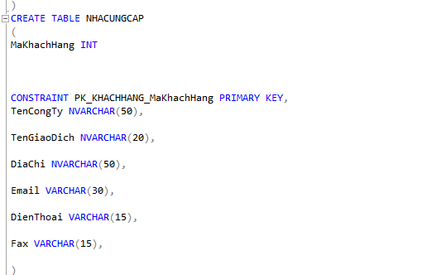

FIgure: 5:SQL sales management code

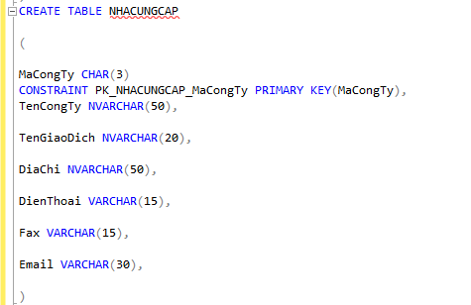

FIgure: 6;SQL sales management code

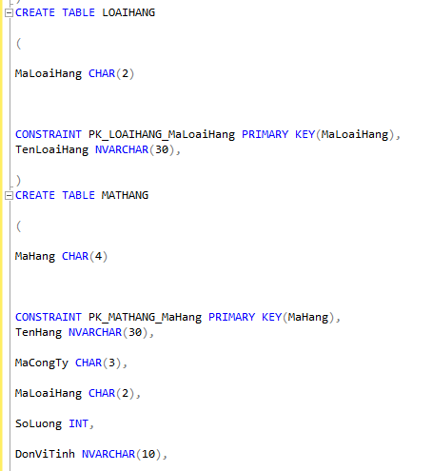

FIgure: 7:SQL sales management code

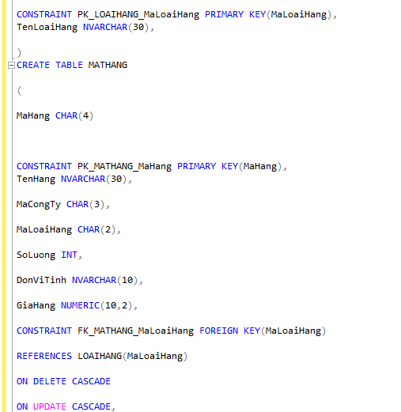

FIgure: 8:SQL sales management code

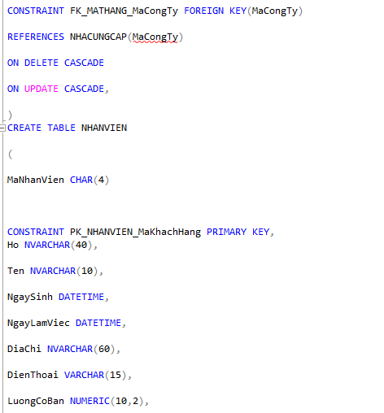

FIgure: 9:SQL sales management code

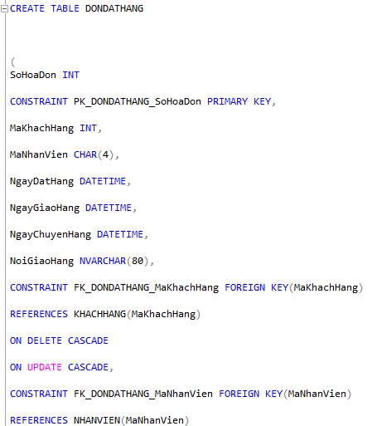

FIgure: 10:SQL sales management code

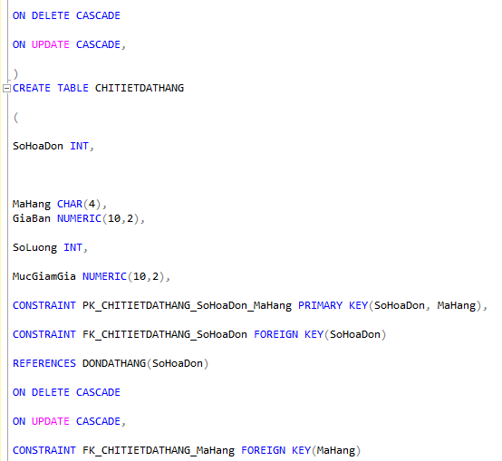

FIgure: 11:SQL sales management code

# C.Conclusion

The above is all the knowledge I have gained in the past lessons and I have outlined the steps to create a complete SQL program. How to create a sales management program and can apply more types of management.

Thank you so much for reading my post

# D.References

<https://erdplus.com/standalone>

<https://stackoverflow.com/questions/1516960/anatomy-of-a-distributed-system-in-php>

<https://dev.to/lontchi12/database-design-of-a-restaurant-management-system-from-user-story-to-relational-model-2jp1>

<https://sites.google.com/site/dbi202databasesystem/database-design>

<https://www.harvard.edu/>

<https://spaces.w3schools.com/createspace/stepone>

https://fullstack.edu.vn/